AWS Project Self Healing WebApp: Core Network and Application Infrastructure

1. Introduction
This document provides a comprehensive guide for manually replicating the core networking infrastructure and the highly available application tier deployed in AWS. The infrastructure is segmented into public and private tiers across multiple Availability Zones (AZs) to ensure resilience and adherence to security best practices. The application tier utilizes an Application Load Balancer (ALB) and an Auto Scaling Group (ASG) for scalability and fault tolerance. Crucially, the system includes an automated self-healing mechanism using CloudWatch, SNS, and Lambda to address application issues like high CPU utilization.

2. Resources Created Manually
The following components must be created in the specified order to ensure correct dependencies are established. The number of steps has been optimized for console replication.
- Virtual Private Cloud (VPC) (10.0.0.0/16)
- Internet Gateway (IGW)
- Four Subnets (Two Public, Two Private, 2 AZs)
- Elastic IP (EIP) for NAT Gateway
- NAT Gateway (in Public Subnet)
- Public Route Table (Route to IGW)
- Private Route Table (Route to NAT Gateway)
- Three Security Groups (ALB, Bastion, Web Server)
- IAM Role (for EC2 Monitoring/SSM)
- Launch Template (for EC2 configuration)
- Application Load Balancer (ALB), Target Group (TG), and Listener
- Auto Scaling Group (ASG) (Deploys into Private Subnets)
- IAM Role (for Self-Healing Lambda Function)
- SNS Topic and Subscriptions (for alerts and triggering Lambda)
- Lambda Function (for self-healing reboot)
- CloudWatch Alarm (for high CPU)
- CloudWatch Dashboard (for visualization)

3. Step-by-Step Instructions for Resource Replication

3.1. Virtual Private Cloud (VPC) Setup
The foundational network is defined by a custom VPC with DNS enabled.
- Navigate to the VPC service dashboard and click Create VPC.
- Set the IPv4 CIDR block to 10.0.0.0/16.
- Assign the name tag selfheal-app-vpc.
- Verify that DNS Hostnames and DNS Resolution are enabled.
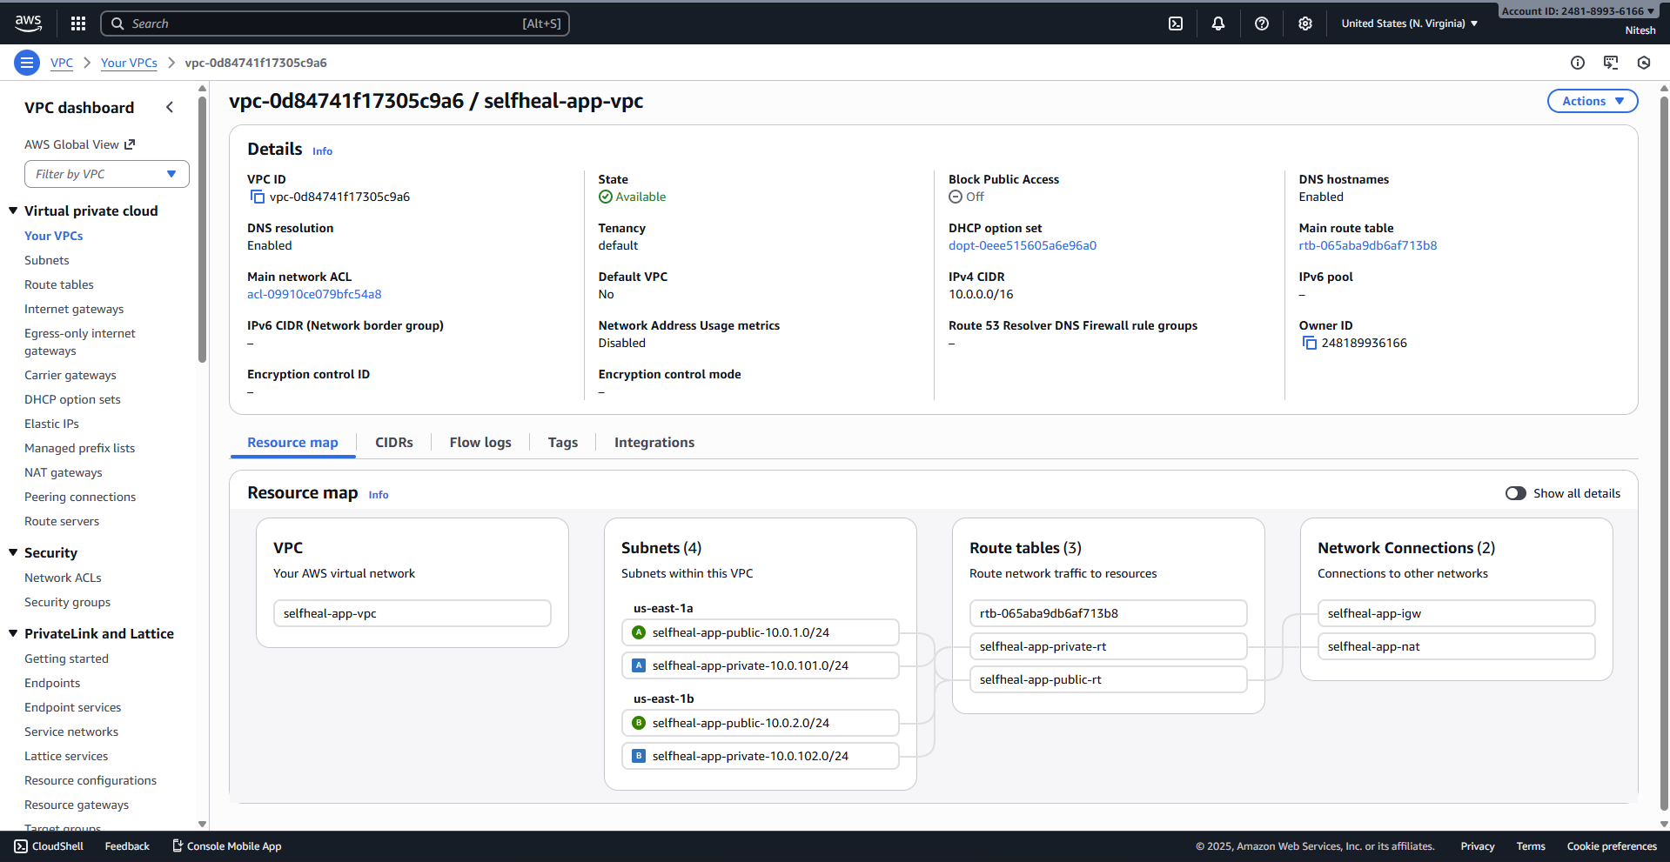

3.2. Internet Gateway (IGW)
The Internet Gateway provides a path for public traffic to enter the VPC.
- Navigate to Internet Gateways and click Create internet gateway.
- Name it selfheal-app-igw.
- Attach the IGW to the selfheal-app-vpc.
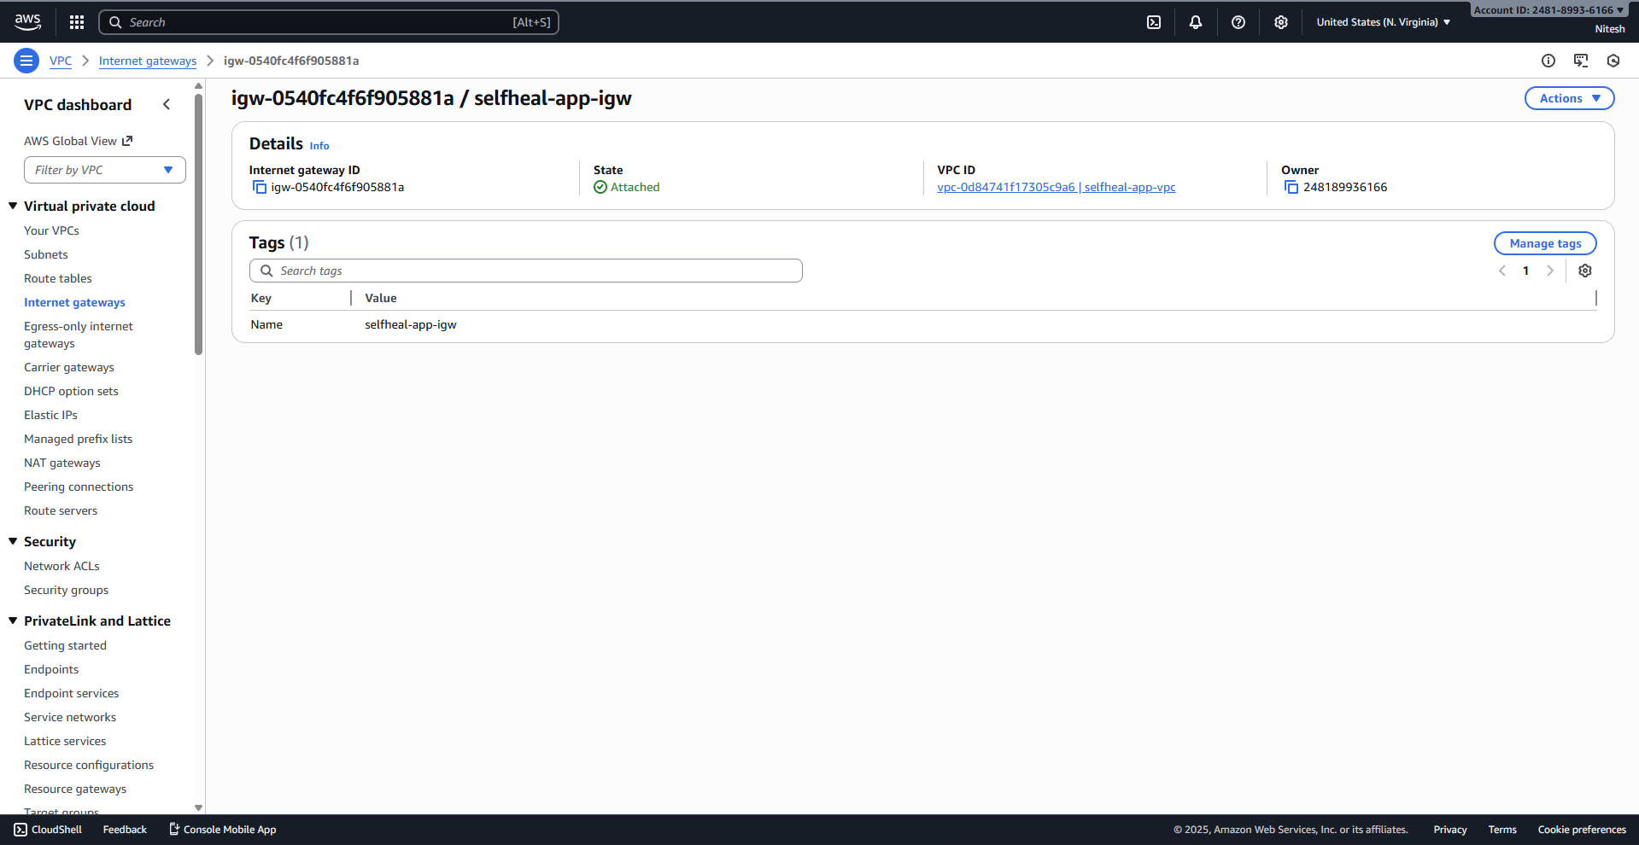

3.3. Subnet Configuration
Four subnets are deployed across two Availability Zones (AZs) for fault tolerance.

3.3.1. Public Subnets
- selfheal-app-public-10.0.1.0/24 (AZ: us-east-1a). Enable Auto-assign public IPv4 address.
- selfheal-app-public-10.0.2.0/24 (AZ: us-east-1b). Enable Auto-assign public IPv4 address.
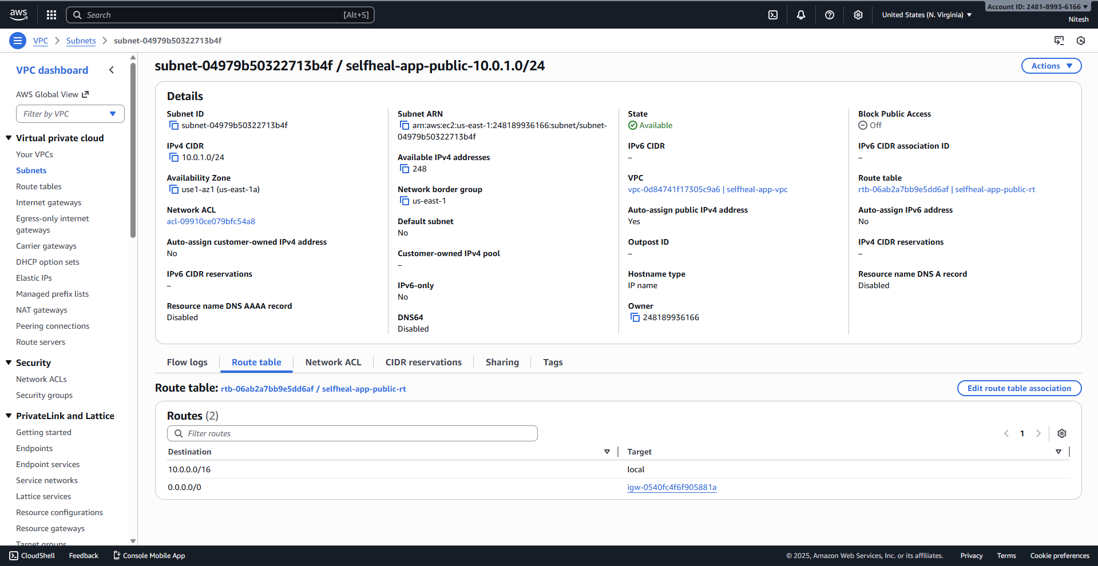
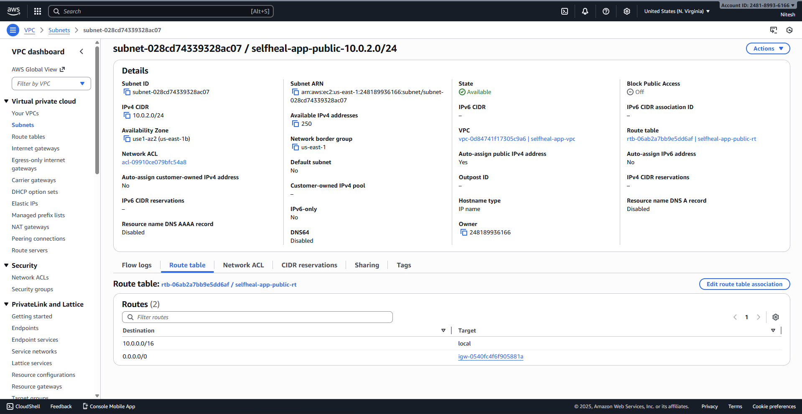

3.3.2. Private Subnets
- selfheal-app-private-10.0.101.0/24 (AZ: us-east-1a).
- selfheal-app-private-10.0.102.0/24 (AZ: us-east-1b).
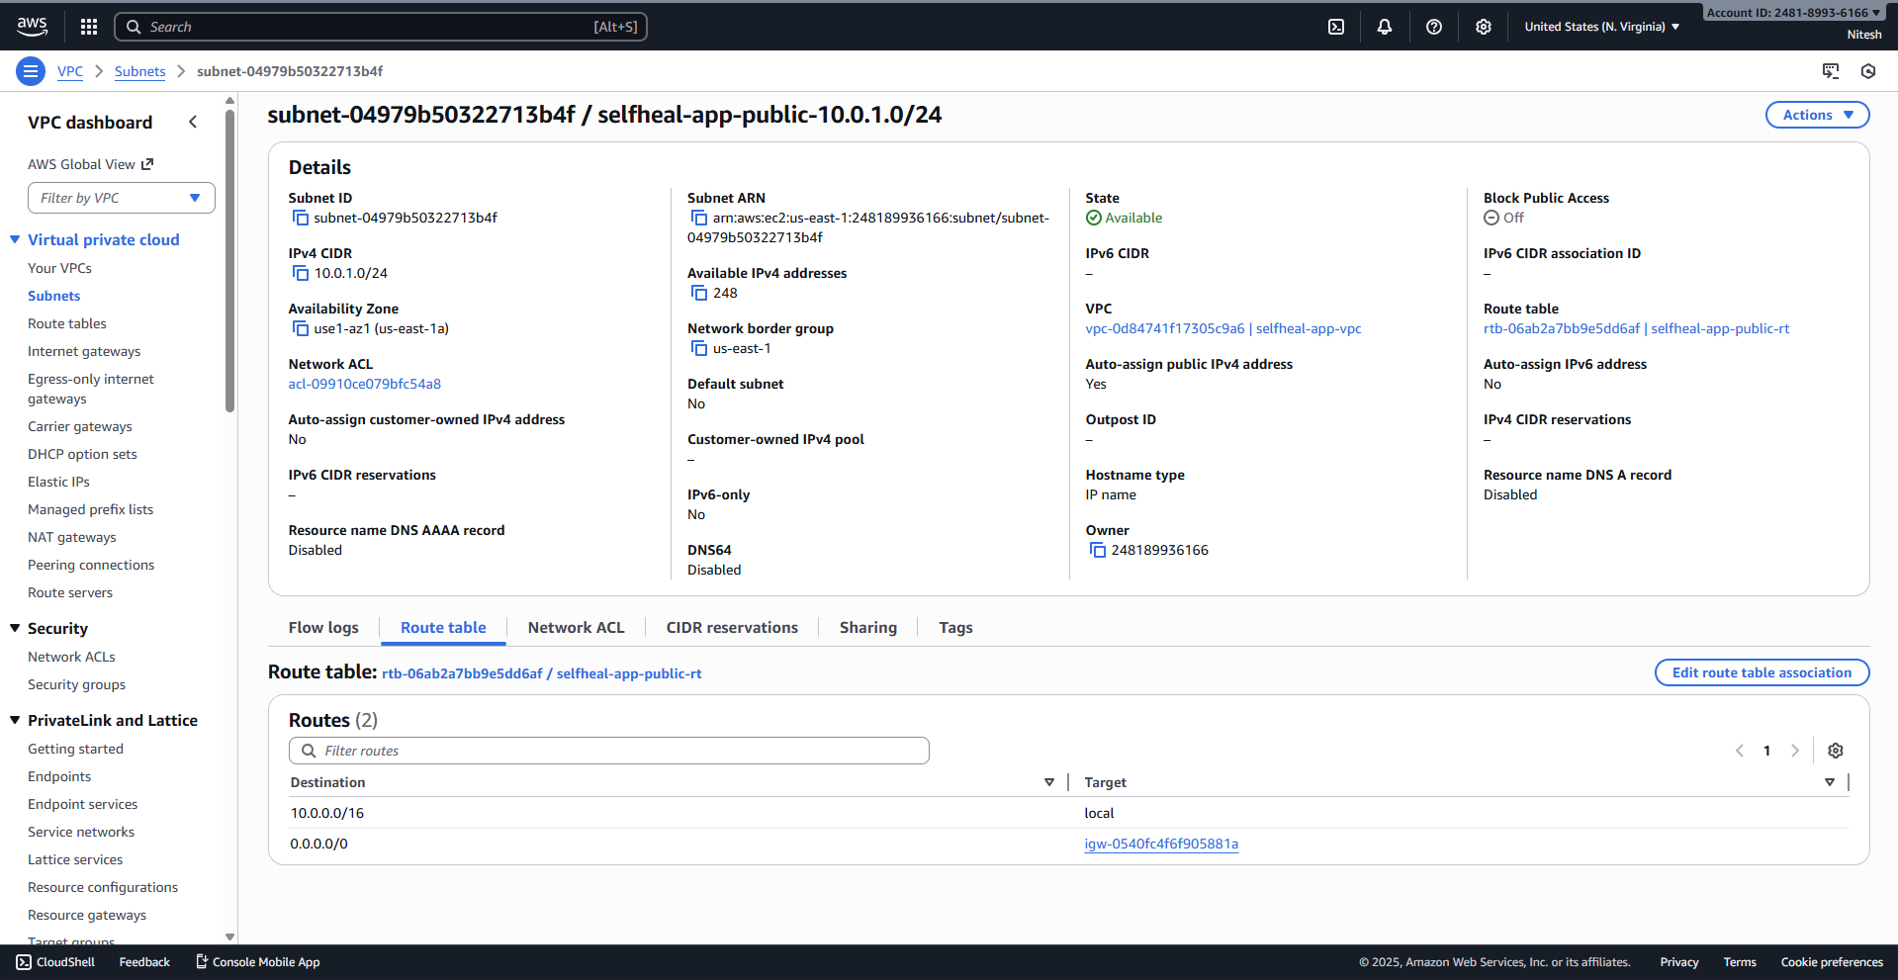
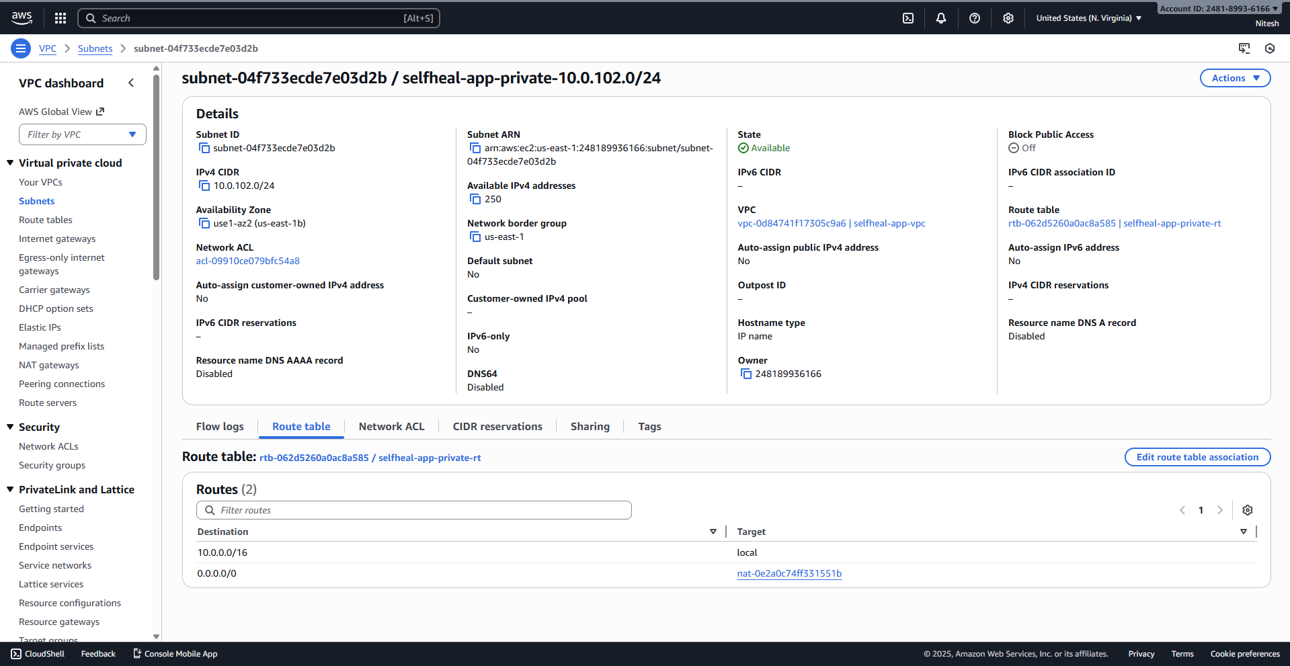

3.4. Elastic IP (EIP) and NAT Gateway
A NAT Gateway is required to allow private instances outbound internet access.
- Allocate Elastic IP: Allocate a new EIP and tag it: Name: selfheal-app-nat-eip.
- Create NAT Gateway: Name it selfheal-app-nat, select the first Public Subnet (10.0.1.0/24), and associate the new EIP.
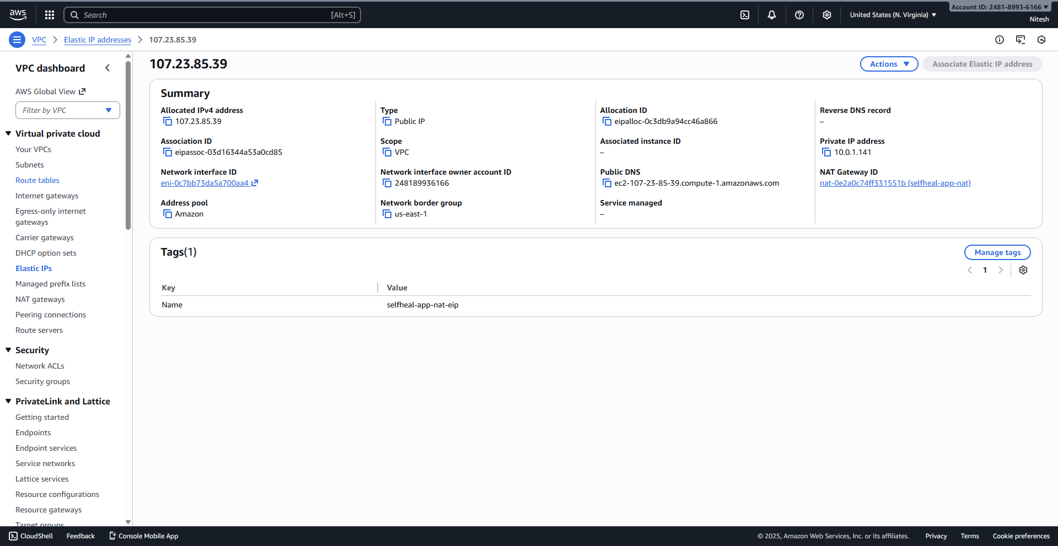
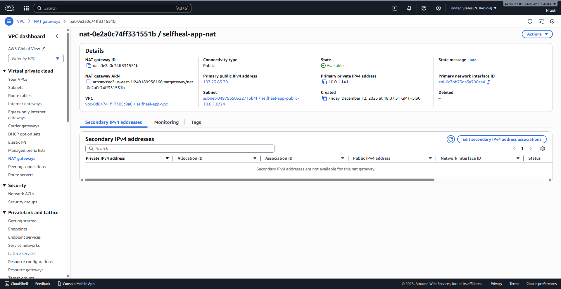

3.5. Routing Table Configuration

3.5.1. Public Route Table
- Create route table selfheal-app-public-rt.
- Add route: Destination 0.0.0.0/0 > Target selfheal-app-igw.
- Associate with both public subnets.
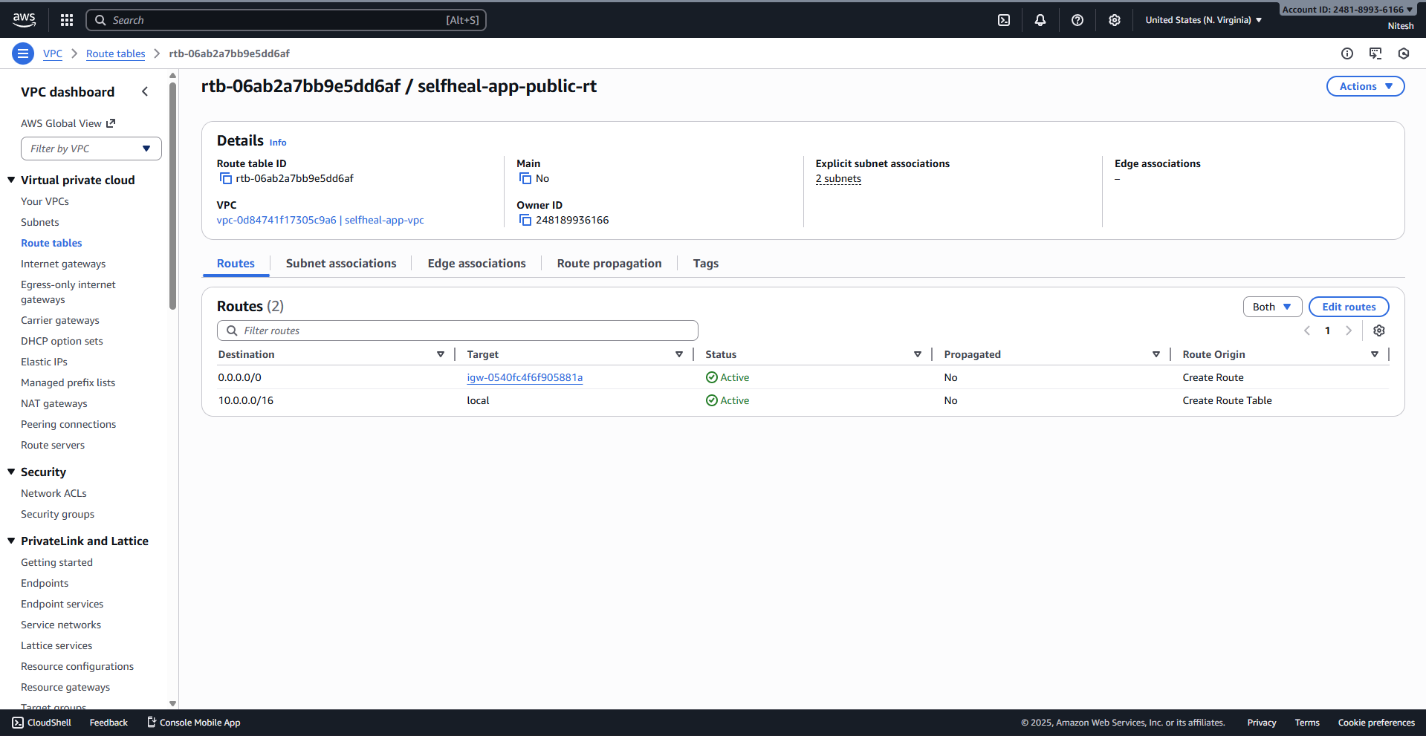

3.5.2. Private Route Table
- Create route table selfheal-app-private-rt.
- Add route: Destination 0.0.0.0/0 > Target selfheal-app-nat.
- Associate with both private subnets.
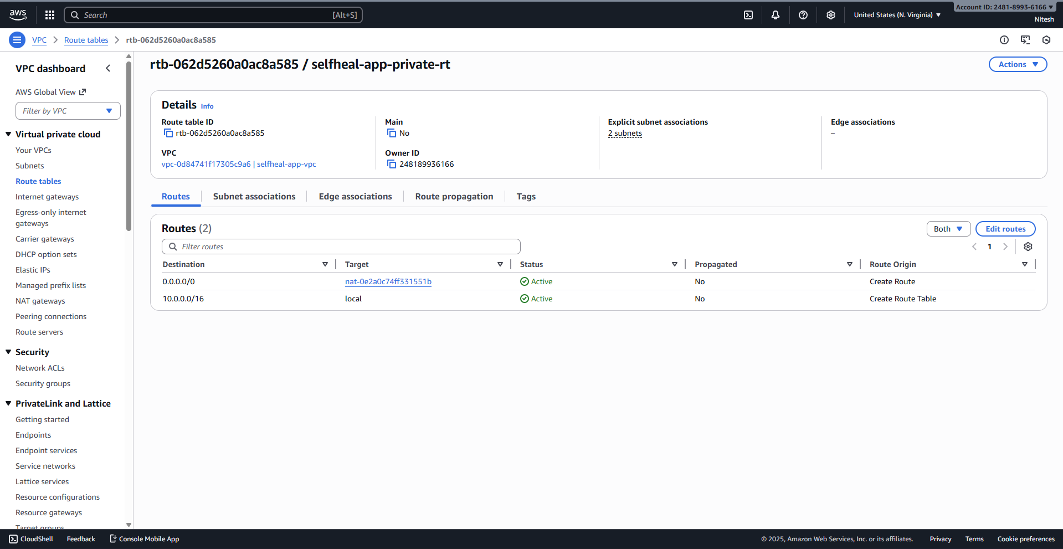

3.6. Security Group Configuration

3.6.1. ALB Security Group (selfheal-app-alb-sg)
- Inbound: HTTP (80) from 0.0.0.0/0 (Anywhere).
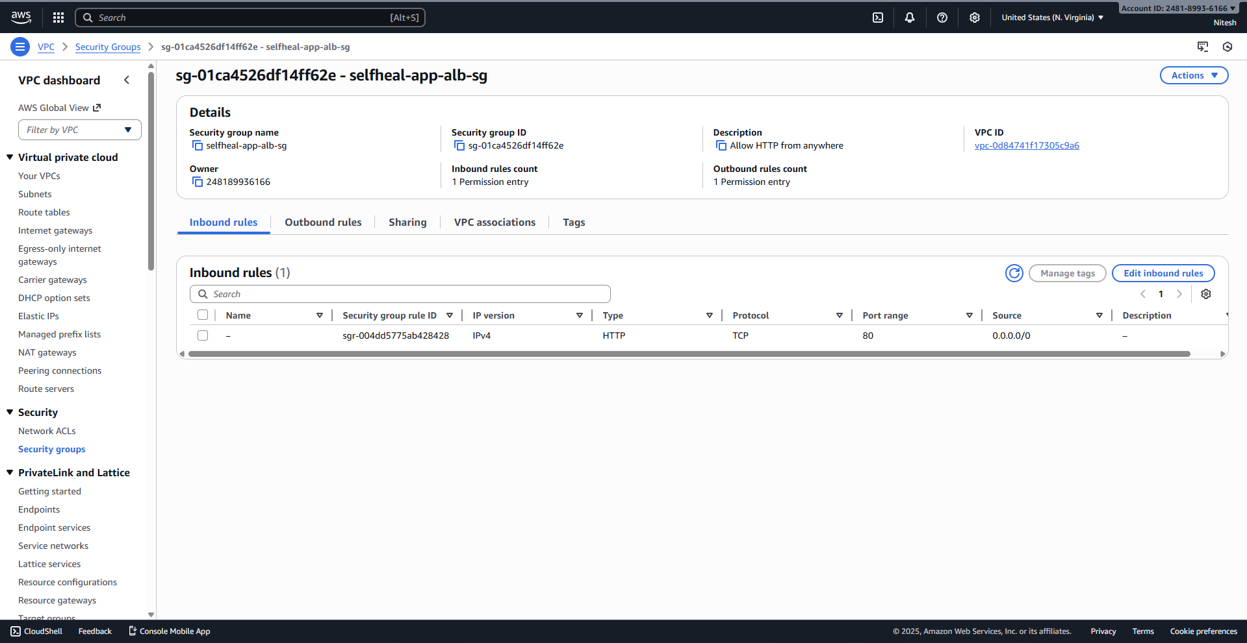

3.6.2. Bastion Security Group (selfheal-app-bastion-sg)
- Inbound: SSH (22) from 0.0.0.0/0.
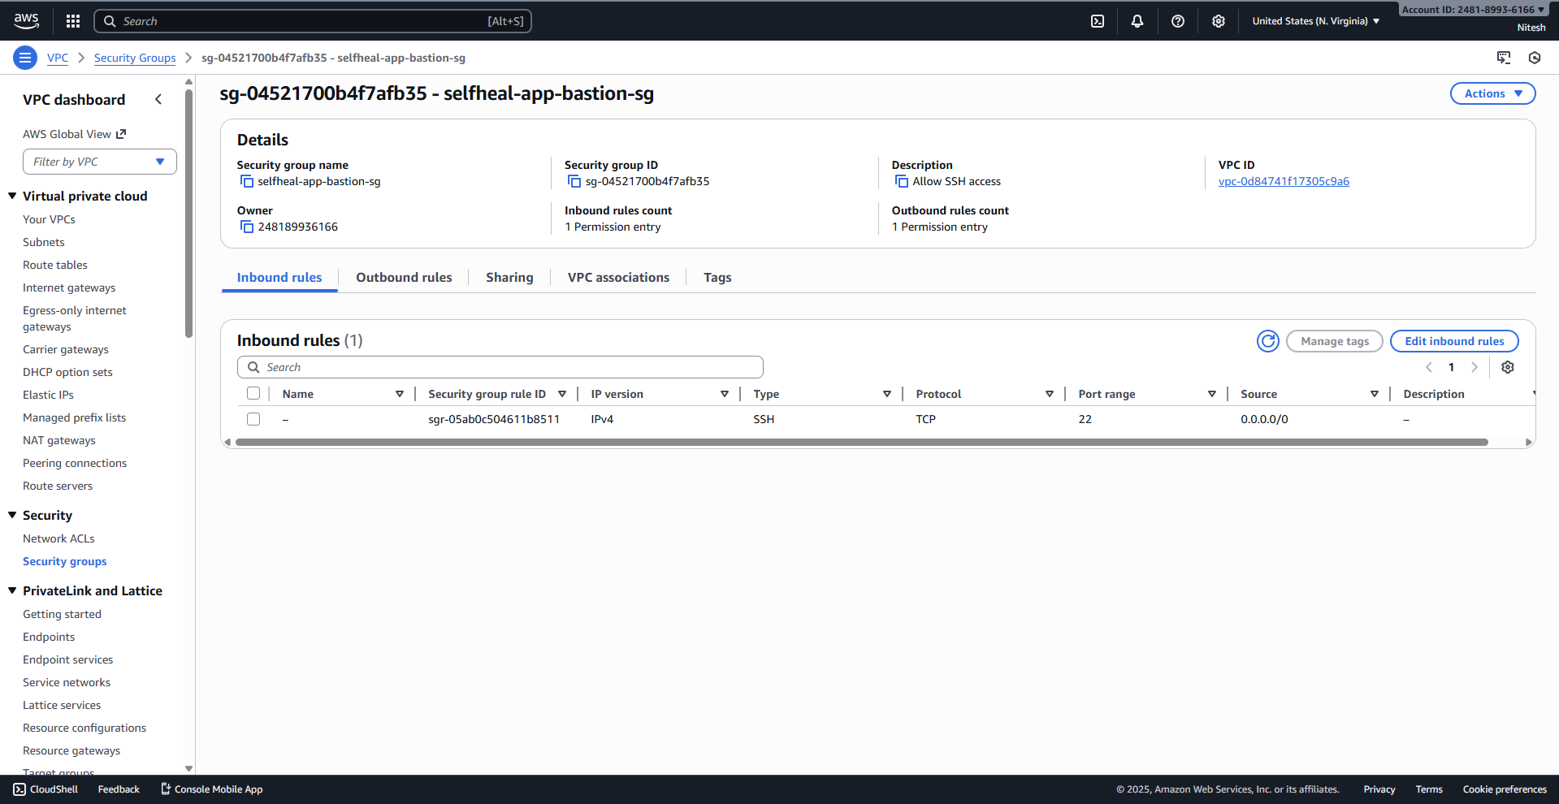

3.6.3. Web Server Security Group (selfheal-app-web-sg)
- Inbound Rule 1 (HTTP): HTTP (80) from Source: selfheal-app-alb-sg ID (Allow traffic only from the ALB).
- Inbound Rule 2 (SSH): SSH (22) from Source: selfheal-app-bastion-sg ID (Allow admin access only from the Bastion Host).
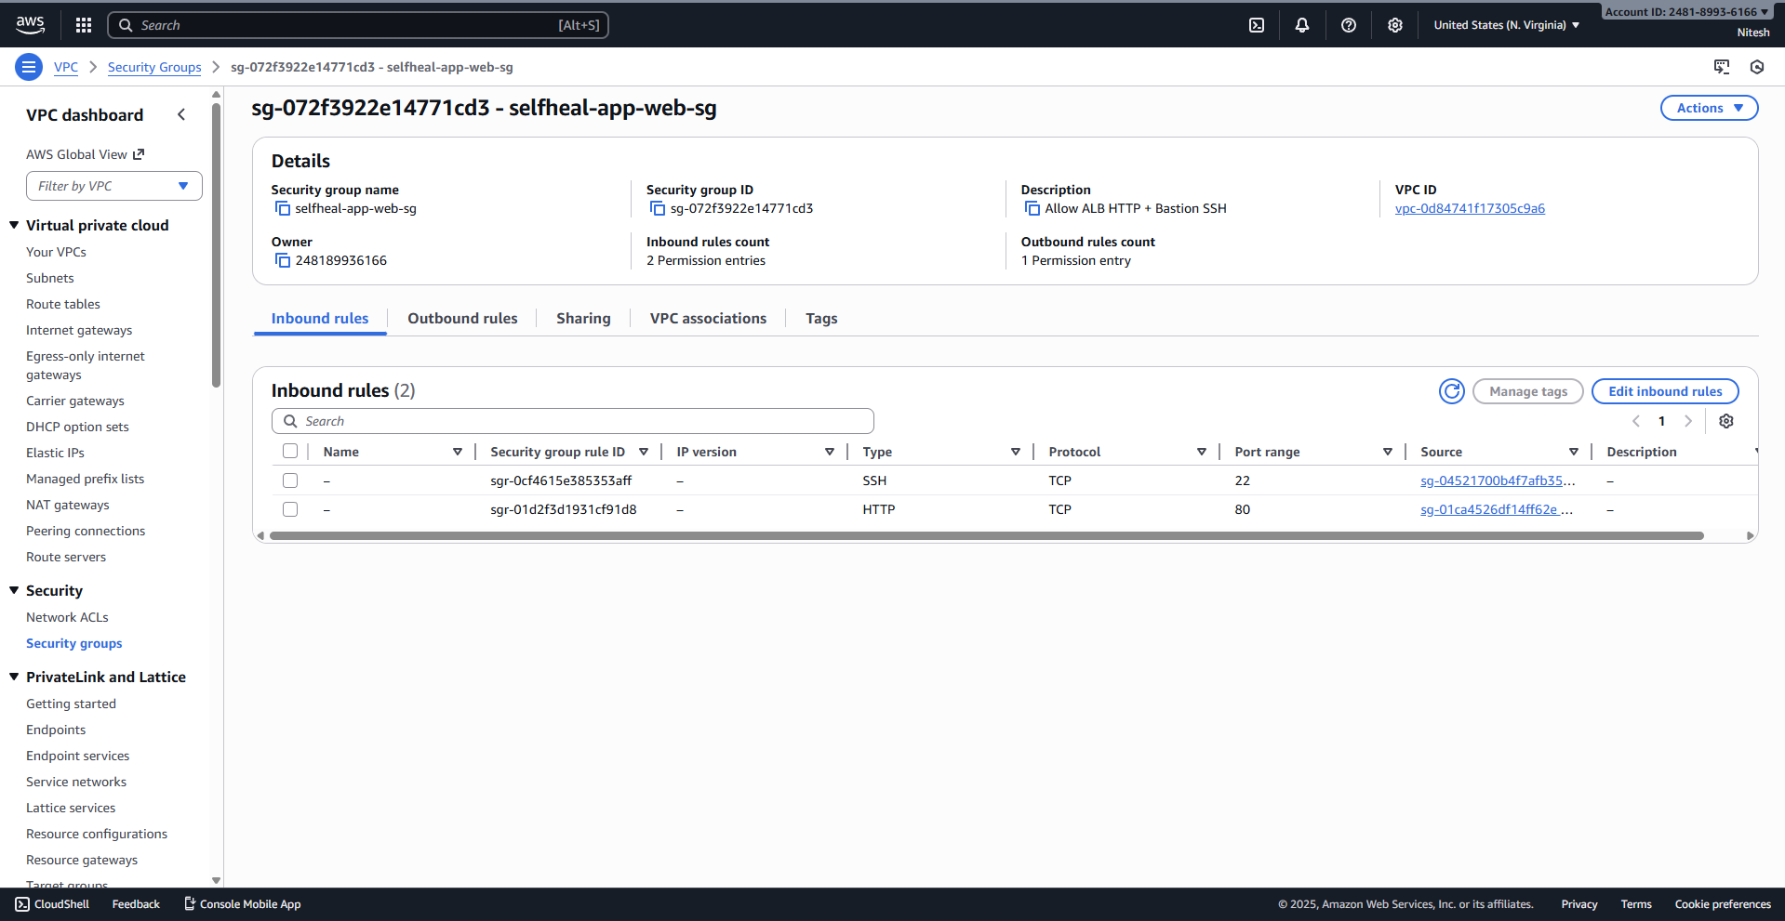

3.7. IAM Role and Instance Profile for EC2 Monitoring
This role grants the Web Server instances permission to write logs and be managed by SSM.
- Create IAM Role: selfheal-app-cw-agent-role for the EC2 service.
- Attach policies: CloudWatchAgentServerPolicy, CloudWatchLogsFullAccess, and AmazonSSMManagedInstanceCore.
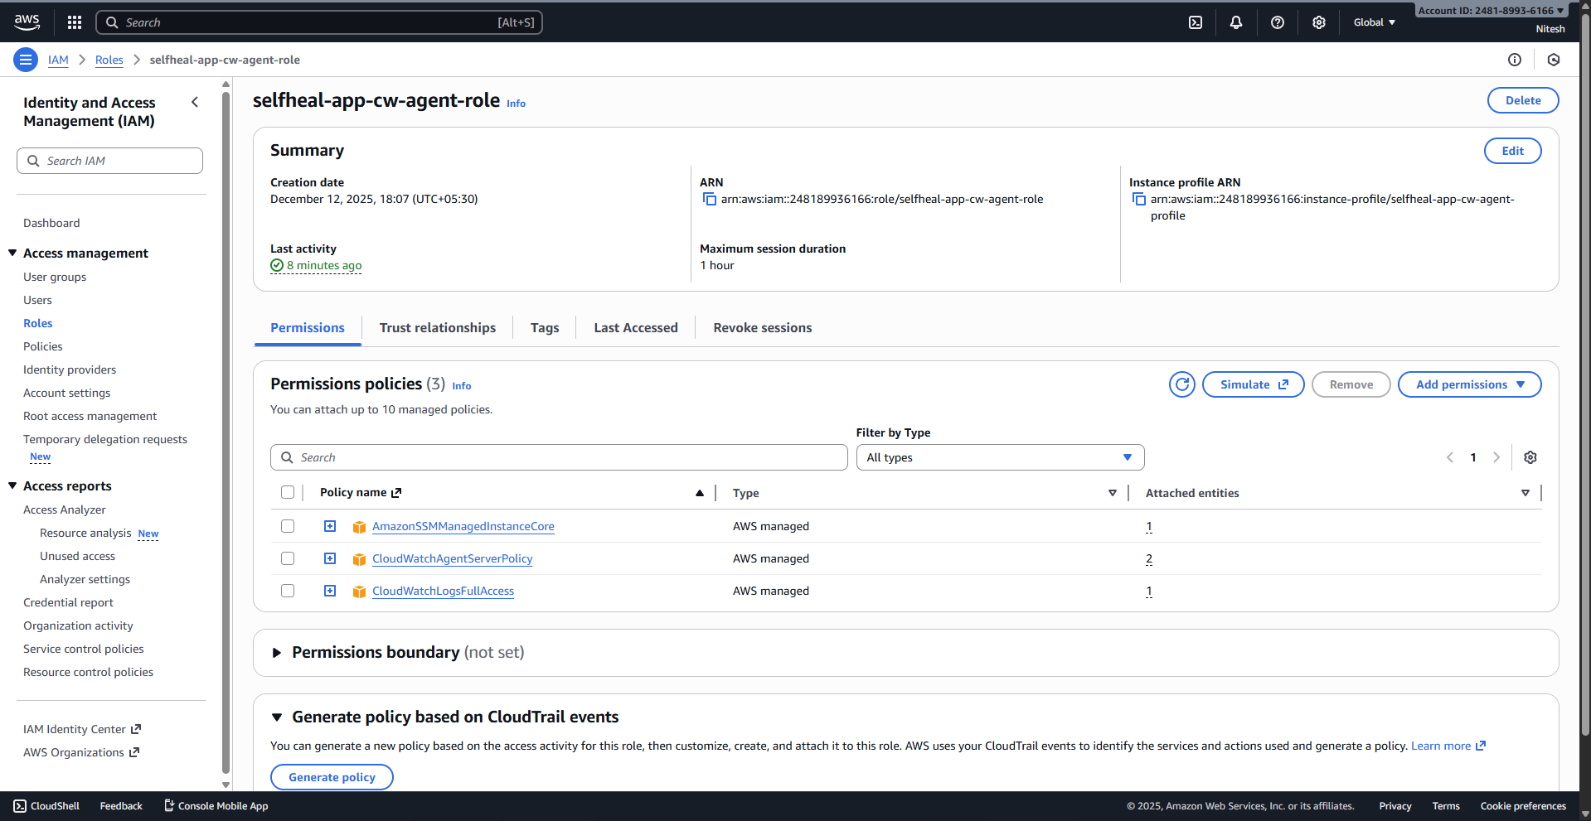

3.8. EC2 Launch Template Creation
- Navigate to Launch Templates and click Create launch template.
- Name: selfheal-app-lt.
- Configuration: t3.micro, Amazon Linux 2 AMI, your key pair.
- Network settings: Select selfheal-app-web-sg.
- Advanced details: Select IAM instance profile: selfheal-app-cw-agent-role.
- User data: Include the necessary bootstrap script (e.g., to install a web server and the CloudWatch Agent).
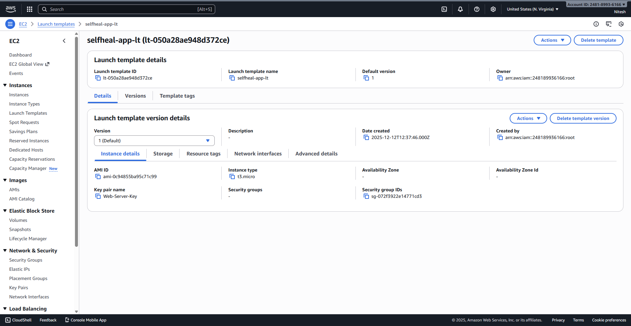

3.9. Application Load Balancer (ALB) Setup
- Create Target Group (selfheal-app-tg): Target type: Instances, Protocol: HTTP:80, VPC: selfheal-app-vpc.
- Create Load Balancer (selfheal-app-alb): Internet-facing, deployed in the two public subnets, using selfheal-app-alb-sg.
- Configure Listener: Set the ALB Listener on port 80 to Forward to the selfheal-app-tg target group.
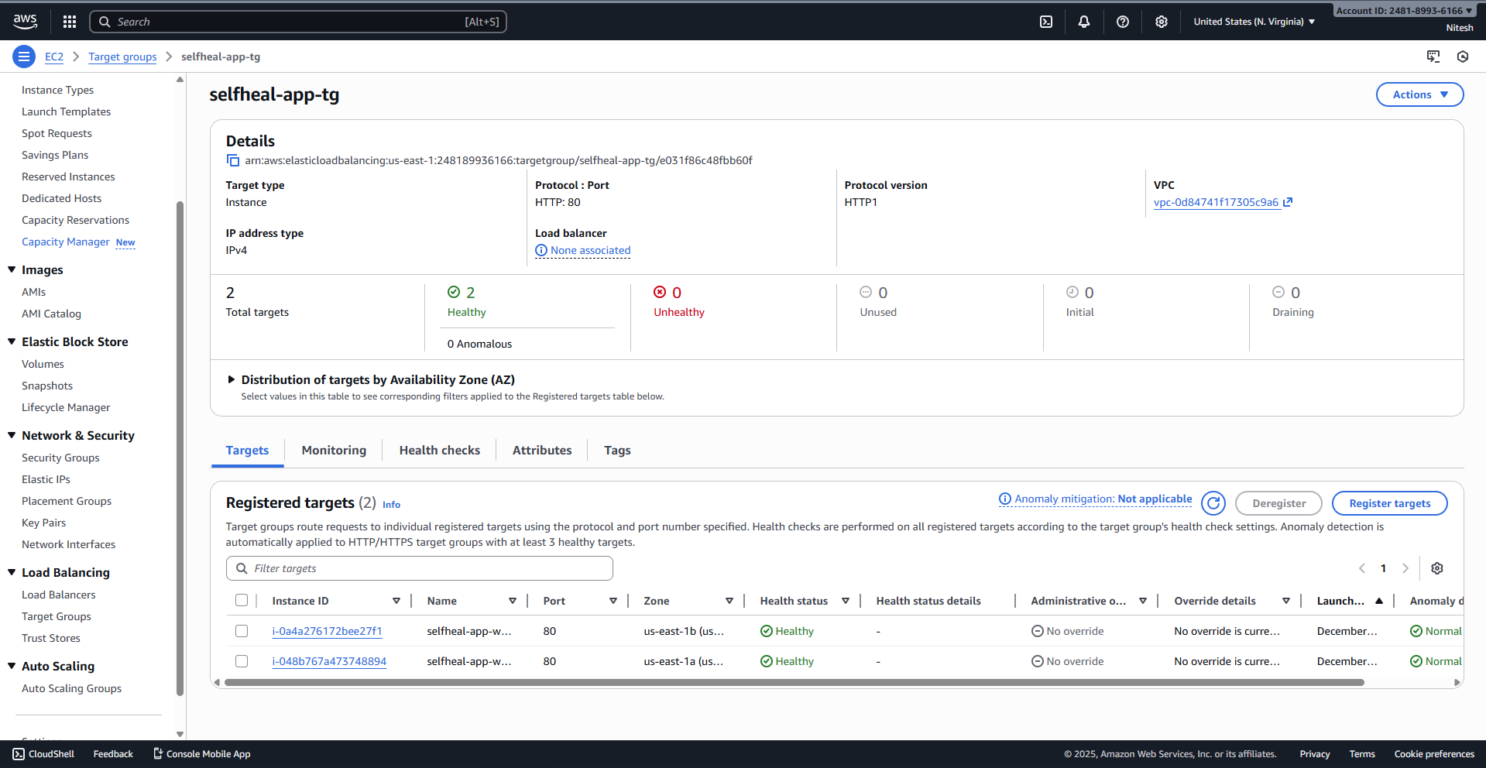
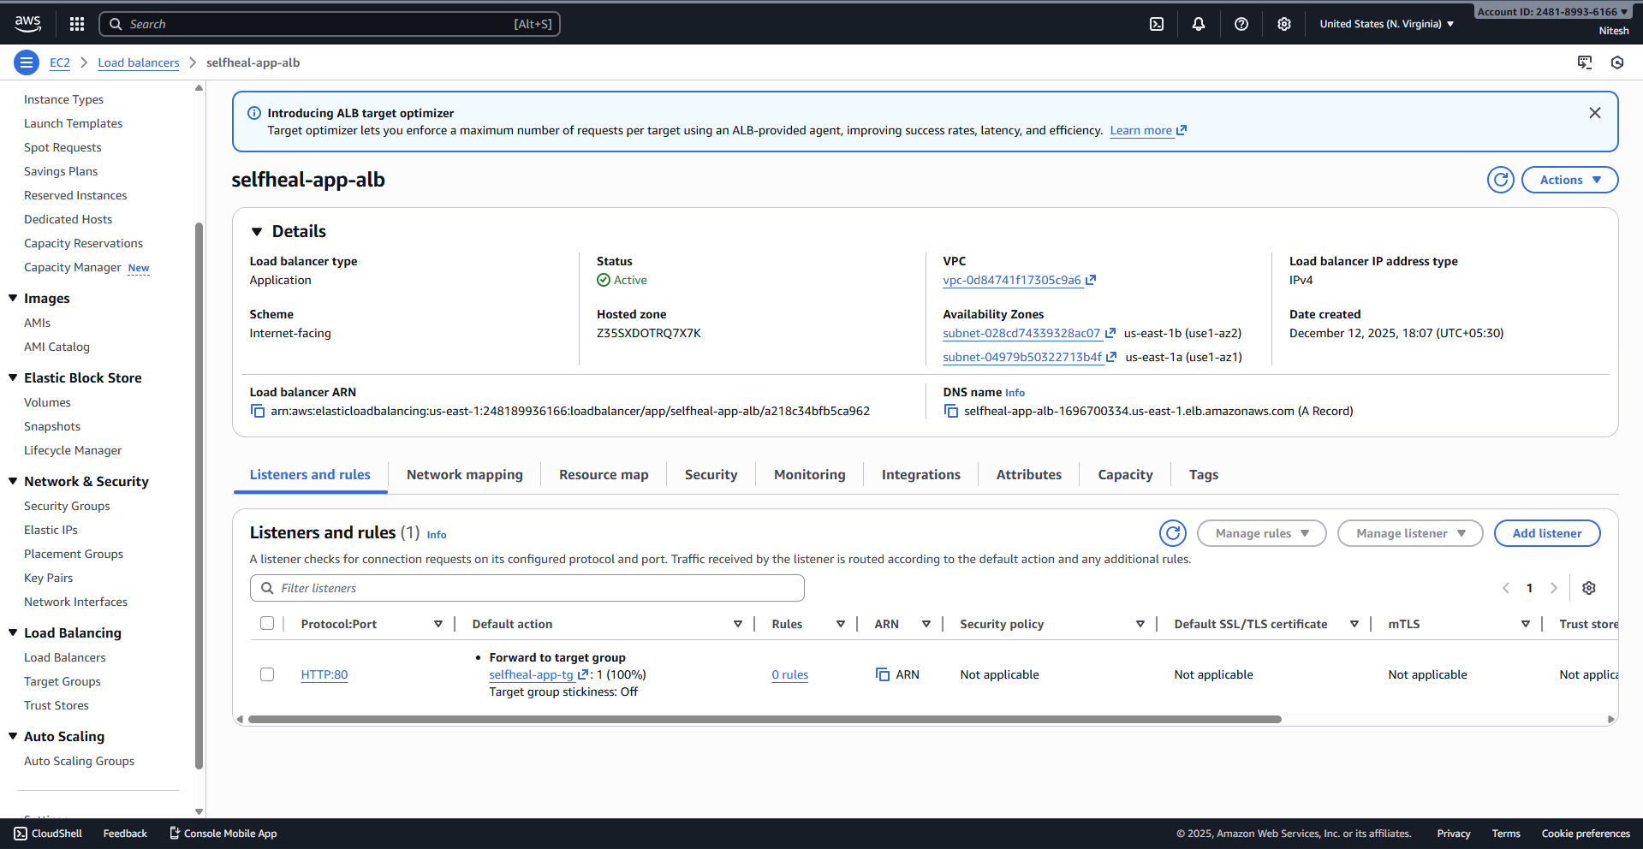

3.10. Auto Scaling Group (ASG) Deployment
- Navigate to Auto Scaling Groups and click Create Auto Scaling group.
- ASG name: selfheal-app-asg.
- Launch template: Select selfheal-app-lt.
- Network: Select the two private subnets.
- Configure advanced options: Attach to an existing load balancer and select the selfheal-app-tg.
- Set capacity: Desired: 2, Min: 2, Max: 4.
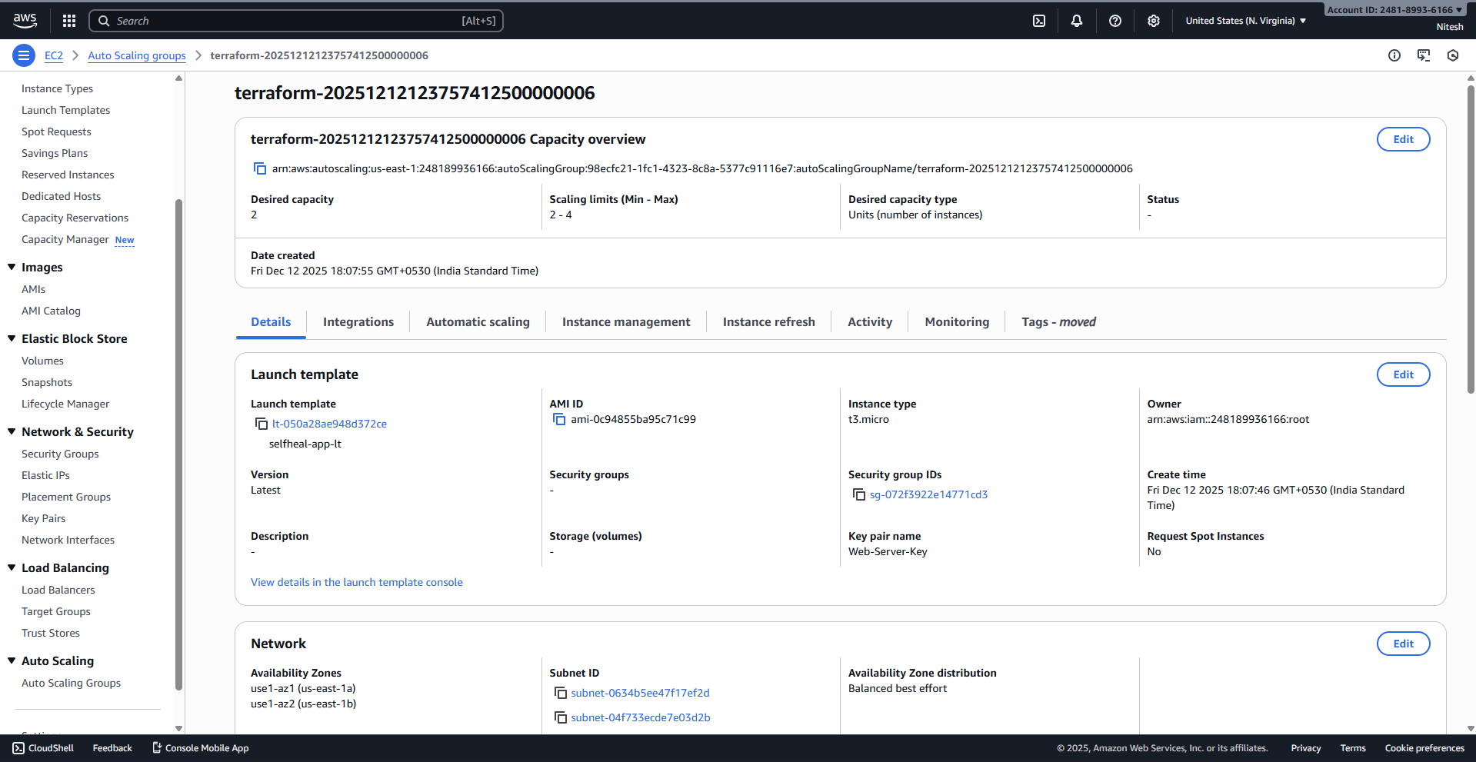
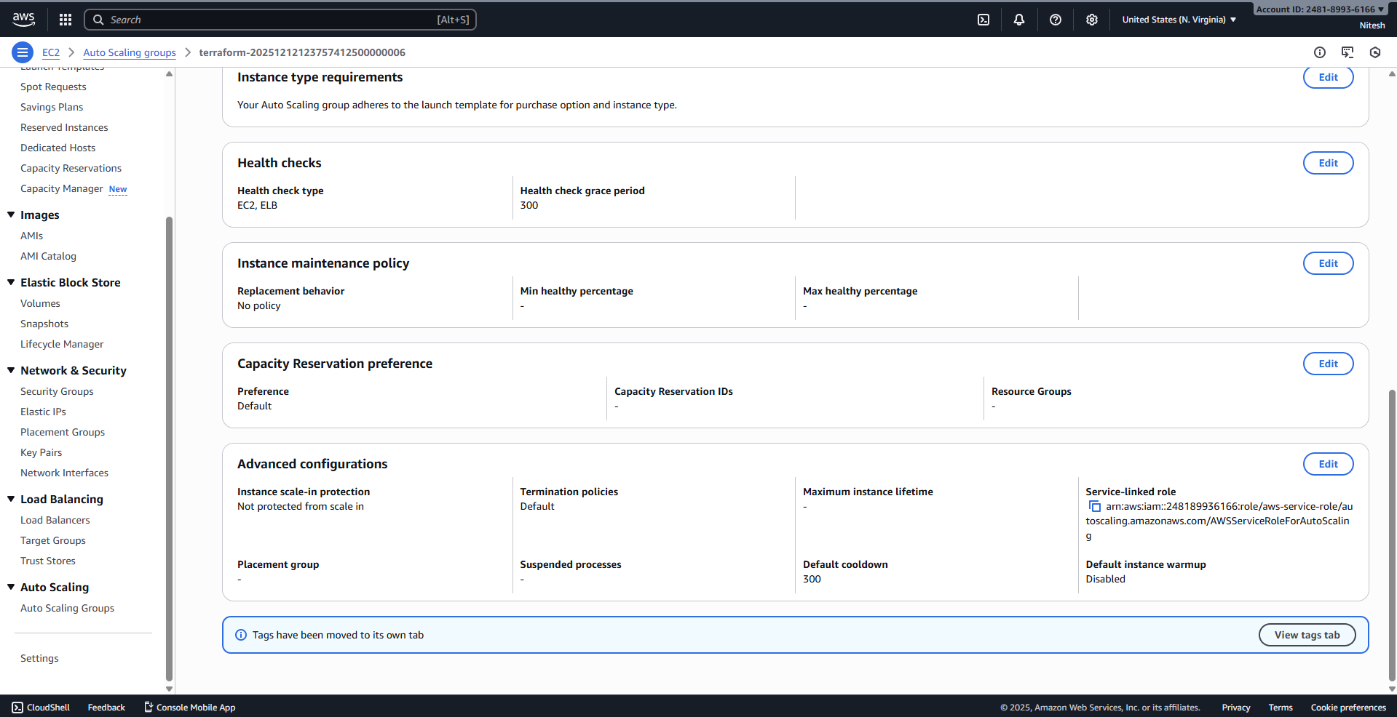

3.11. IAM Role for Self-Healing Lambda
This role allows the Lambda function to reboot EC2 instances and write logs.
- Create IAM Role: selfheal-app-lambda-role for the Lambda service.
- Attach managed policy: AWSLambdaBasicExecutionRole.
- Add Inline Policy: Grant ec2:RebootInstances permissions on * resources.
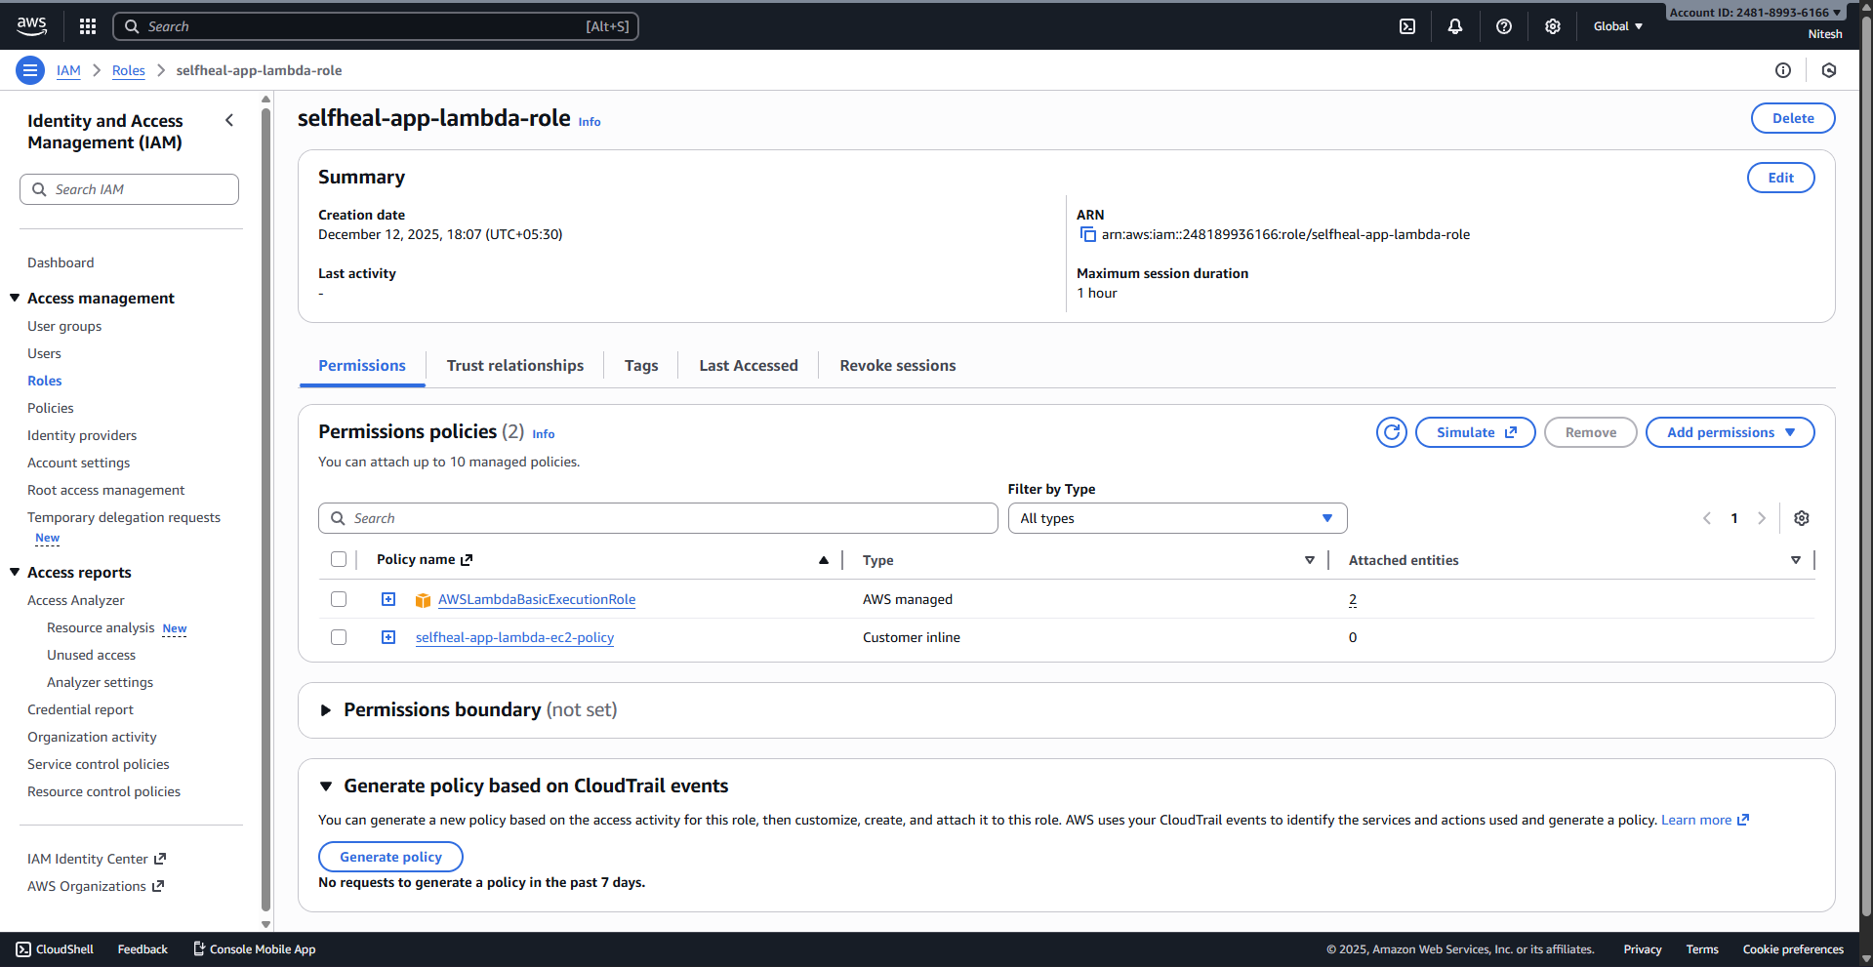

3.12. SNS Topic and Subscriptions (Alerting)
- Create SNS Topic: Type: Standard, Name: selfheal-app-alerts.
- Create Subscriptions:
  - Subscription 1 (Lambda): Protocol: AWS Lambda, Endpoint: ARN of selfheal-app-selfheal-lambda (from next step).
  - Subscription 2 (Email): Protocol: Email, Endpoint: your_email@example.com (Requires confirmation).
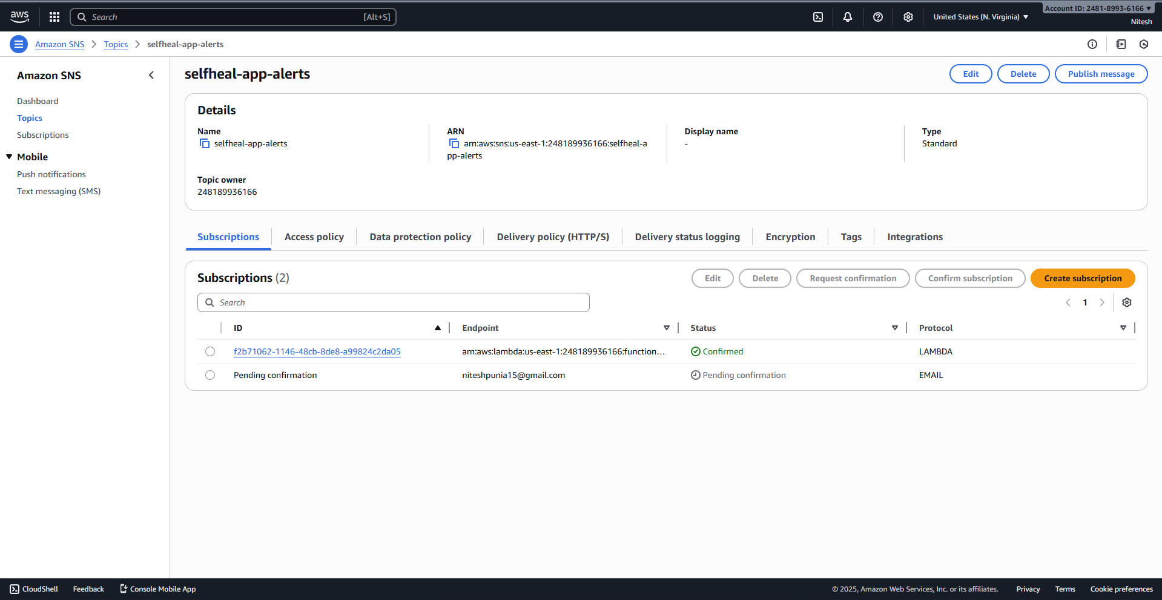
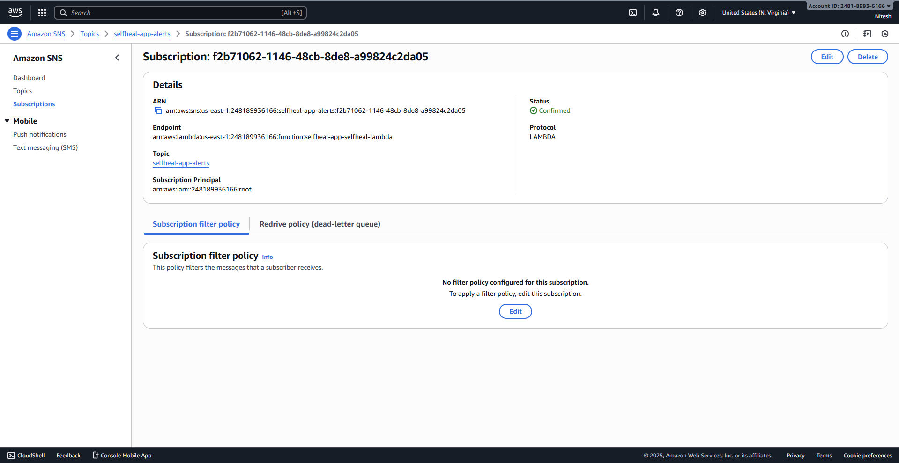

3.13. Lambda Function for Self-Healing
This Python function is triggered by the SNS topic to parse the CloudWatch alarm and reboot the affected EC2 instance.
- Create Function: Name: selfheal-app-selfheal-lambda, Runtime: Python 3.10, Role: selfheal-app-lambda-role.
- Configure Code: (The complete function code is available in the Git repository at https://github.com/Nitesh0815/Self-Healing-WebApp/manually-created-resources/lambda/handler.py)
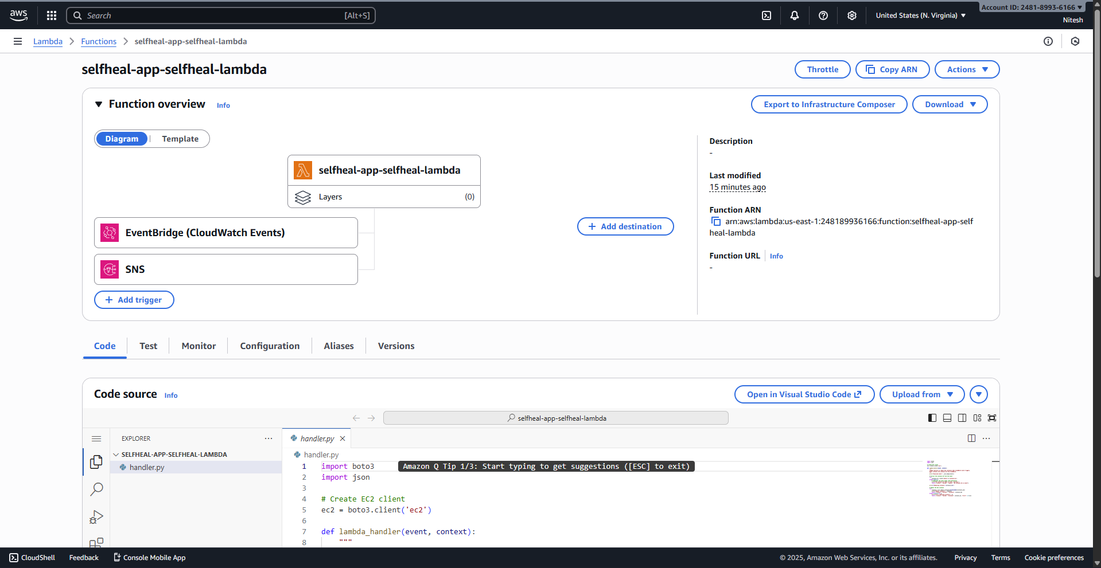
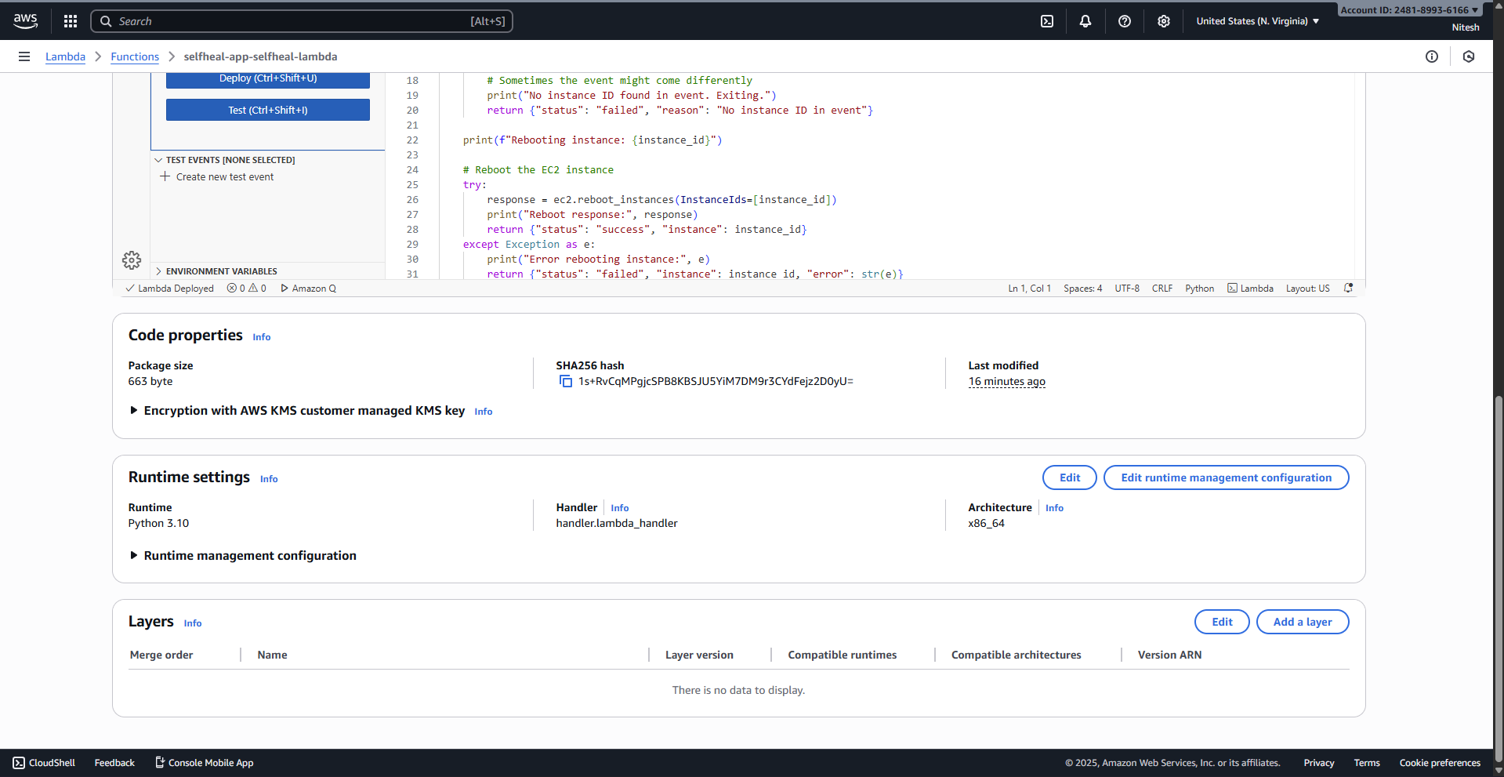

3.14. CloudWatch Alarm Configuration
The alarm monitors CPU utilization and triggers the SNS topic, initiating the self-healing process.
- Navigate to CloudWatch > Alarms and click Create alarm.
- Metric: EC2 > CPUUtilization (select one ASG instance).
- Condition: CPUUtilization is Greater than 95 Percent for 1 out of 1 data points (5 minutes period).
- Action: Alarm state trigger: In alarm, Select selfheal-app-alerts SNS topic.
- Name the alarm: selfheal-app-high-cpu.
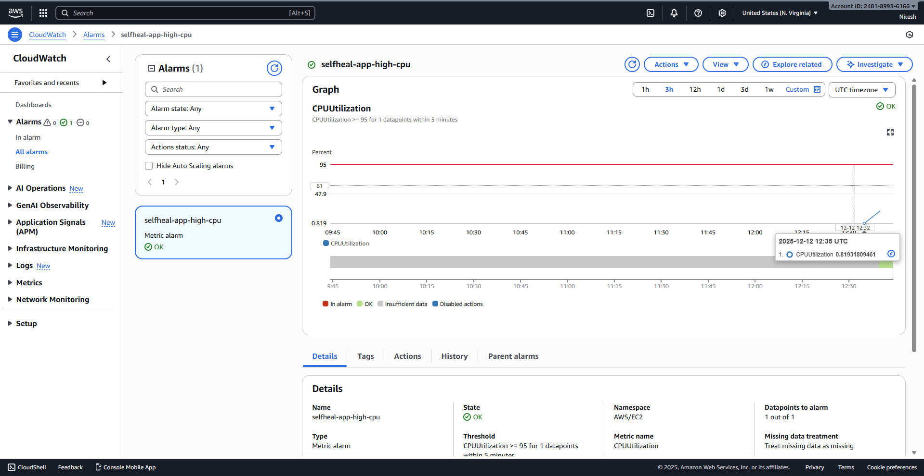

3.15. CloudWatch Dashboard
A dashboard provides an overview of application health.
- Create Dashboard: selfheal-app-dashboard.
- Add widgets for:
  - EC2 CPU Utilization (for all web instances).
  - ALB Healthy Host Count (for selfheal-app-tg).
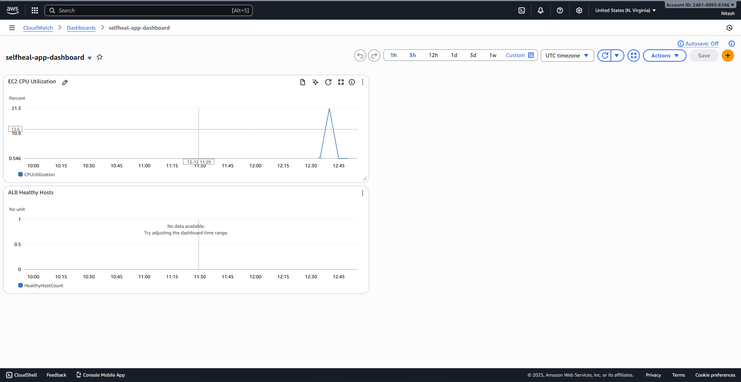

4. Self-Healing Demonstration and Verification
The following steps demonstrate the functionality of the self-healing mechanism:
- Application Running: The web application is accessible via the ALB DNS name, confirming basic connectivity.
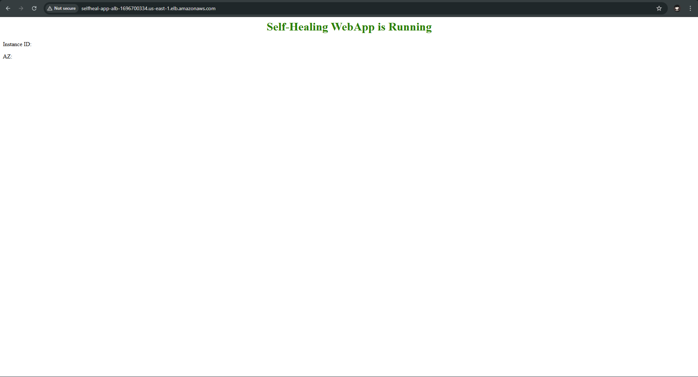
- Load Generation (Triggering the Alarm): An SSH session (via the Bastion host) is used to connect to one of the private web server instances. A stress command is run in the background to intentionally spike the CPU utilization above the 95% threshold.
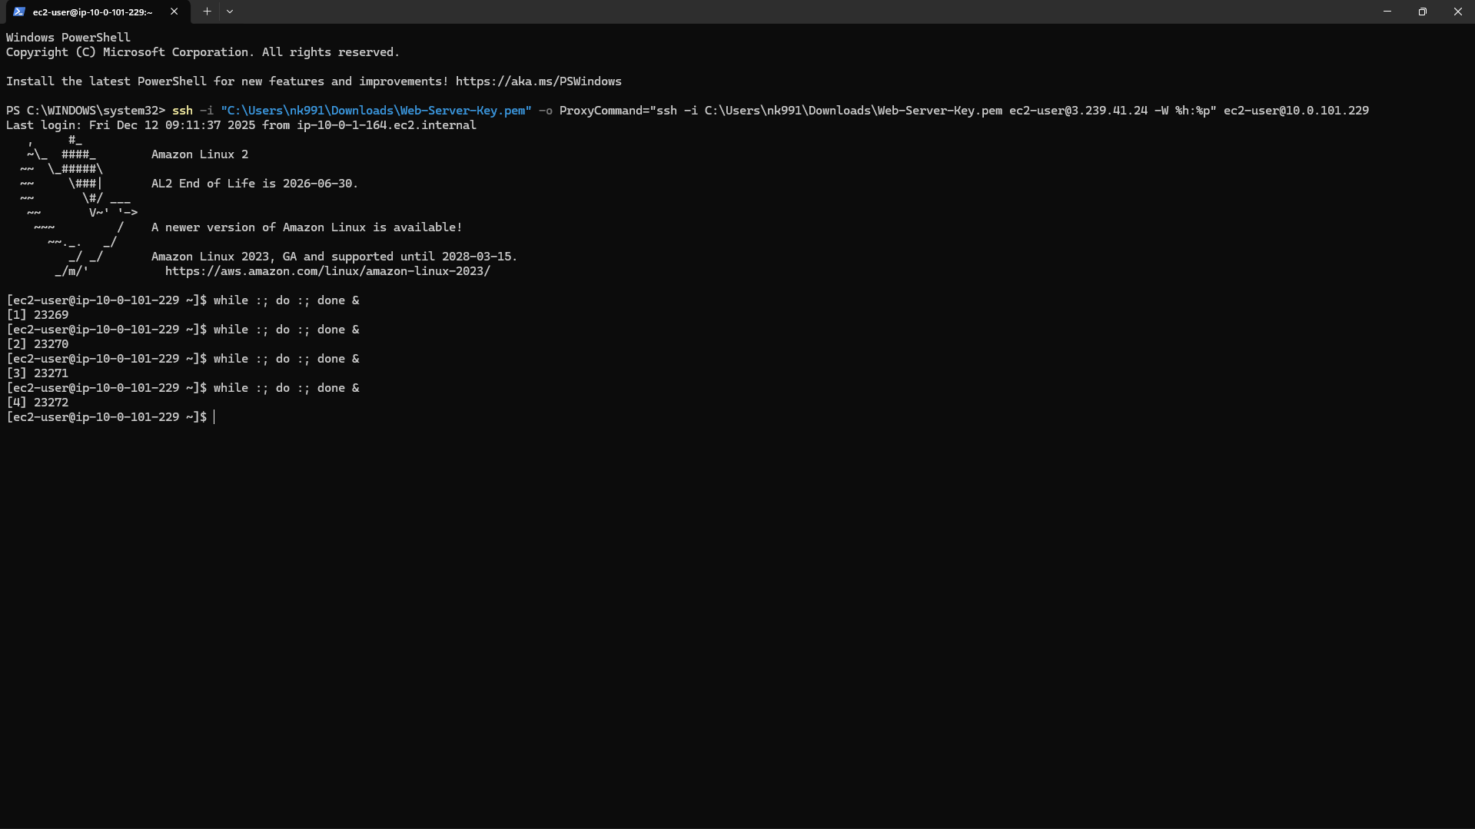
- Alarm State Change: CloudWatch detects the sustained high CPU usage (above 95%) and the alarm transitions from OK to ALARM.
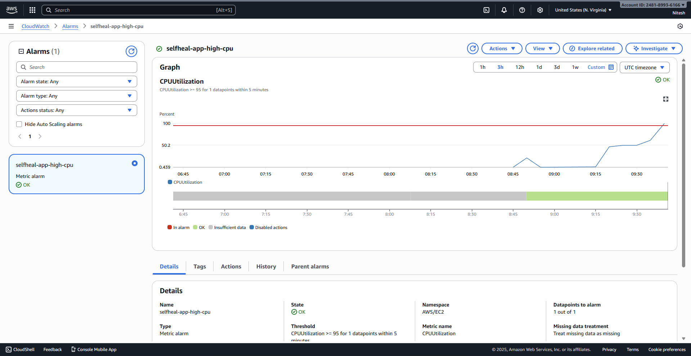
- Notification and Action Confirmation: The IN ALARM state triggers the SNS topic, which invokes the Lambda function (the self-healing action). An email notification is received, confirming the alarm state change and noting that the Lambda function was triggered, which executes the EC2 instance reboot.

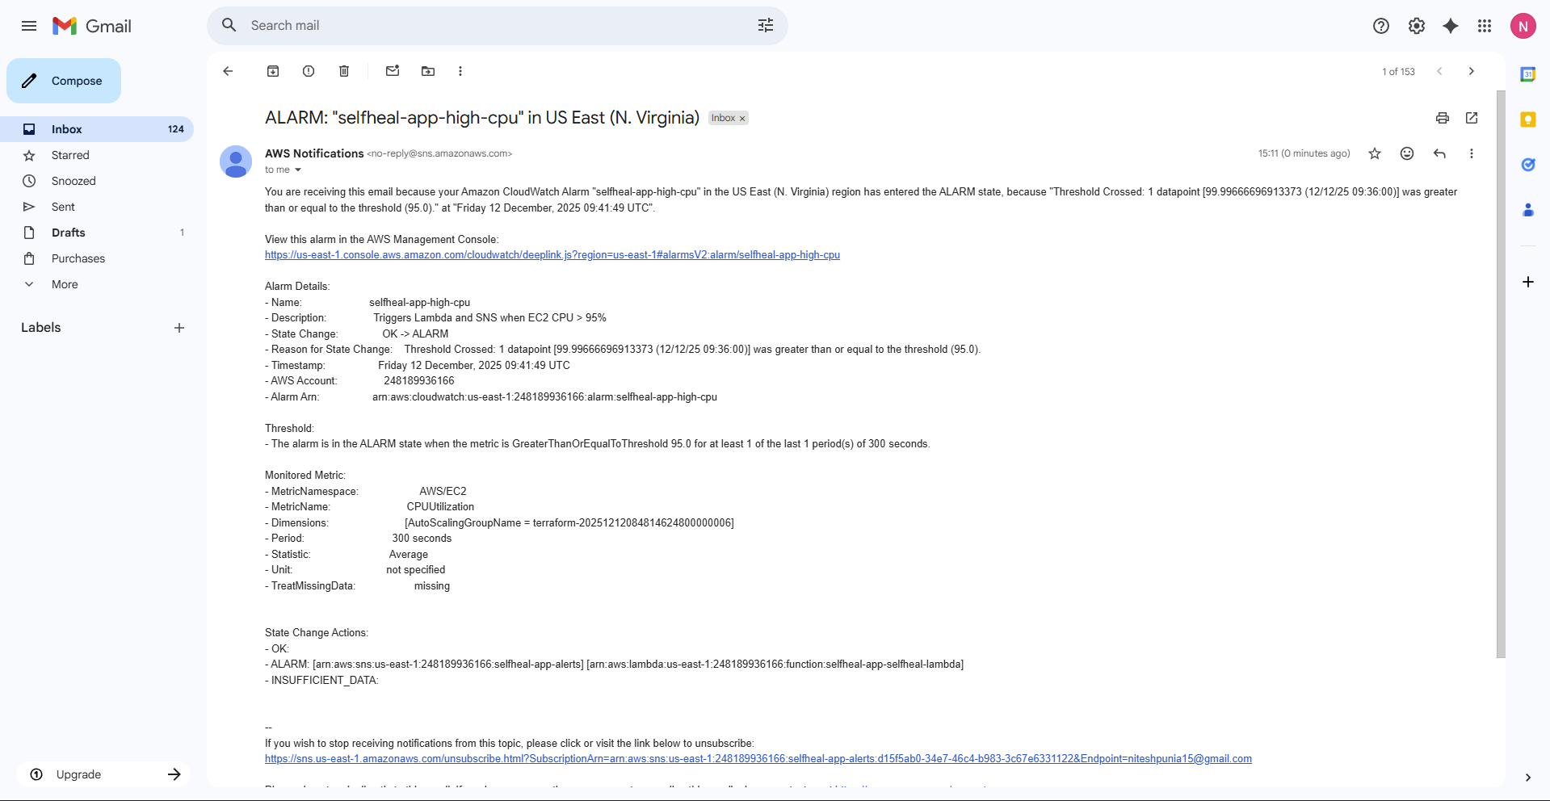

5. Conclusion
This report successfully documents the manual replication of a resilient, multi-AZ AWS infrastructure, complete with a highly available application tier using ALB and ASG. Most importantly, the implementation of the CloudWatch, SNS, and Lambda integration establishes an effective self-healing pipeline. This automation ensures that performance issues, such as excessive CPU load, are automatically remediated by rebooting the affected instance, thus significantly improving the overall reliability and operational efficiency of the application.

